In loving memory

of

James (Jimmy) Jackson

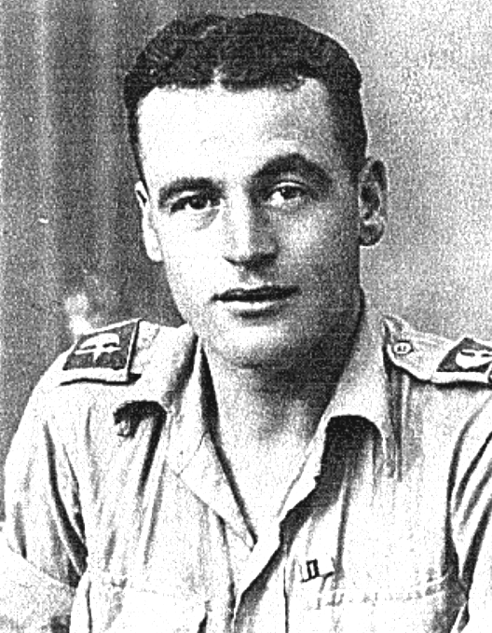

10th November 1921 – 8th July 2004

St Andrew’s Church

Orford with Longford

Monday 19th July 2004

followed by interment at Fox Covert Cemetery

Order of Service

ALL STAND as the funeral procession enters the church. Once the family are seated, please SIT.

The Priest reads one or more scriptural sentences.

Introduction

Priest: We meet in the name of Jesus Christ, who died and was raised to the glory of God the Father. Grace and mercy be with you.
All: Amen.

The priest introduces the service

Priest: Let us pray: ( please remain seated)

Almighty God, you judge us with infinite mercy and justice, and love everything you have made. In your mercy turn the darkness of death into the dawn of new life, and the sorrow of parting into the joy of heaven; through our Saviour, Jesus Christ. Amen

Priest: Merciful Father, hear our prayers and comfort us; renew our trust in your Son, whom you raised from the dead; strengthen our faith that all who have died in the love of Christ will share in his resurrection; who lives and reigns with you, in the unity of the Holy Spirit, one God, now and for ever. Amen

The Ministry of the Word

Hymn: “The Old Rugged Cross” (please stand)

On a hill far away stood an old rugged cross,
The emblem of suff'ring and shame;
and I love that old cross where the dearest and best
For a world of lost sinners was slain.
So I'll cherish the old rugged cross
Till my trophies at last I lay down;
I will cling to the old rugged cross
And exchange it some day for a crown.

Oh, the old rugged cross, so despised by the world,
Has a wondrous attraction for me;
For the dear Lamb of God left his glory above
To bear it to dark Calvary.

So I'll cherish the old rugged cross

In the old rugged cross, stained with blood so divine,
A wondrous beauty I see;
For 'twas on that old cross Jesus suffered and died
To pardon and sanctify me.

So I'll cherish the old rugged cross

To the old rugged cross I will ever be true,
Its shame and reproach gladly bear;
Then He'll call me some day to my home far away,
Where his glory for ever I'll share.

So I'll cherish the old rugged cross

The Scriptural Reading

Please sit for a reading from the book of Revelation (Rev. 21. 1-7)

Then I saw a new heaven and a new earth, for the first heaven and the first earth had passed away, and there was no longer any sea. I saw the Holy City, the new Jerusalem, coming down out of heaven from God, prepared as a bride beautifully dressed for her husband. And I heard a loud voice from the throne saying, "Now the dwelling of God is with men, and he will live with them. They will be his people, and God himself will be with them and be their God. He will wipe every tear from their eyes. There will be no more death or mourning or crying or pain, for the old order of things has passed away."

He who was seated on the throne said, "I am making everything new!"
Then he said, "Write this down, for these words are trustworthy and true."
He said to me: "It is done. I am the Alpha and the Omega, the Beginning and the End. To him who is thirsty I will give to drink without cost from the spring of the water of life. He who overcomes will inherit all this, and I will be his God and he will be my son.

The Address

The Prayers:

Priest: God of mercy, Lord of life, you have made us in your image to reflect your truth and light: we give you thanks for Jimmy, for the grace and mercy he received from you, for all that was good in his life, and especially for the memories we treasure today.

(after a short period of silence)

Lord, in your mercy
All: hear our prayer.

Priest: You promised eternal life to those who believe. Remember for good this your servant Jimmy as we also remember him. Bring all who rest in Christ into the fullness of your kingdom where sins have been forgiven and death is no more.

Lord, in your mercy
All: hear our prayer.

Priest: Your mighty power brings joy out of grief and life out of death. Look in mercy on Jimmy’s wife Ena, his daughter Ena and son in law, Stephen, and granddaughter Laura, and all who mourn at this time. Give them patient faith in times of darkness. Strengthen them with the knowledge of your love.

Lord, in your mercy
All: hear our prayer.

Priest: You are tender towards your children and your mercy is over all your works. Heal the memories of hurt and failure. Give us the wisdom and grace to use aright the time that is left to us here on earth, to turn to Christ and follow in his steps in the way that leads to everlasting life.

Lord, in your mercy
All: hear our prayer.

God of mercy, entrusting into your hands all that you have made and rejoicing in our communion with all your faithful people, we make our prayers through Jesus Christ our Saviour. Amen.

Priest: Let us pray with confidence as our Saviour has taught us

All: Our Father, who art in heaven, hallowed be thy name; thy kingdom come; thy will be done; on earth as it is in heaven. Give us this day our daily bread. And forgive us our trespasses, as we forgive those who trespass against us. And lead us not into temptation; but deliver us from evil. For thine is the kingdom, the power and the glory, for ever and ever. Amen.

Hymn: “Make me a channel of your peace”
based on the Prayer of St Francis of Assisi

Make me a channel of your peace.
Where there is hatred let me bring your love.
where there is injury, your pardon, Lord,
and where there's doubt, true faith in you.

Oh Master, grant that I may never seek
so much to be consoled as to console,
to be understood, as to understand,
to be loved, as to love with all my soul.

Make me a channel of your peace.
Where there's despair in life, let me bring hope.
Where there is darkness, only light,
and where there's sadness, ever joy.

Oh Master, grant that I may never seek
so much to be consoled as to console,
to be understood, as to understand,
to be loved, as to love with all my soul.
Make me a channel of your peace.
It is in pardoning that we are pardoned,
in giving of ourselves that we receive,
and in dying that we're born to eternal life.

Commendation and Farewell [please remain standing]

Priest: Let us commend Jimmy to the mercy of God our Maker and Redeemer.

The coffin is sprinkled with holy water taken from the font

Priest: With this water we call to mind Jimmy’s baptism. As Christ went through the deep waters of death for us, so may he bring us to the fullness of resurrection life with Jimmy and all the redeemed.

God our creator and redeemer, by your power Christ conquered death and entered into glory. Confident of his victory and claiming his promises, we entrust Jimmy to your mercy in the name of Jesus our Lord, who died and is alive and reigns with you, now and for ever. Amen

All: Heavenly Father, in your Son Jesus Christ you have given us a true faith and a sure hope. Strengthen this faith and hope in us all our days, that we may live as those who believe in the communion of saints, the forgiveness of sins and the resurrection to eternal life; through Jesus Christ our Lord. Amen.

Priest: May God, in his infinite love and mercy, bring the whole Church, living and departed in the Lord Jesus, to a joyful resurrection, and the fulfilment of his eternal kingdom. Amen.

As the procession leaves church, the Nunc Dimittis may be read. Please follow the family.

Acknowledgement: Common Worship: Pastoral Services, material from which is included in this service, is copyright © The Archbishops’ Council (2000)

Heartfelt thanks to all who helped in many ways
during the last two weeks.

Special thanks to all the District Nurses
from the Eric Moore Health Centre
for their help and kindness
especially Mary – we couldn’t have done without you.

Donations to St Rocco’s Hospice may be sent to
21 Beck Yeat,
Coniston
LA21 8HT

Please feel free to take this Order of Service with you.

